**Indian Institute of Information Technology, Vadodara**

Software Engineering

IT - 304

Team - 04 ( DeepBench )

**SURVEY REPORT**

**Team Members**

Tarun Bhardwaj (Leader)

Monika Singh

Satyam Kumar

Shubham Poddar

Rajat Soni

Kshitij Khinchi

1. Which are the different activities in which you need to gather students who are interested in that activity?
2. Cultural Activities 65(62.5%)
3. Going for trip 80(76.9%)
4. Outdoor Playing 66(63.5%)
5. Searching representatives for various events. 37(35.6%)
6. Some kind of discussion 60(57.7%)
7. Study during exams. 48(46.2%)
8. Playing Computer Games 49(47.1%)
9. While going for movie. 62(59.6%)

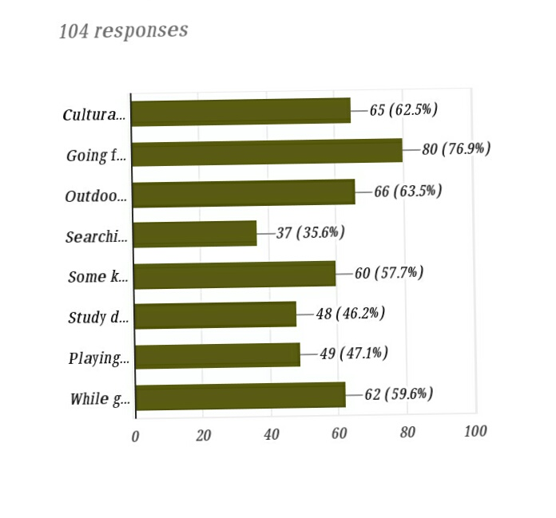

**Conclusion:**

1. How do you gather other colleagues (not from your near ones) for such activities?
2. Using Social Media 44.2%
3. Going Door to Door to each person 12.5%
4. Call Everyone 21.2%
5. Spread through your friends 21.2%
6. Others… 1%

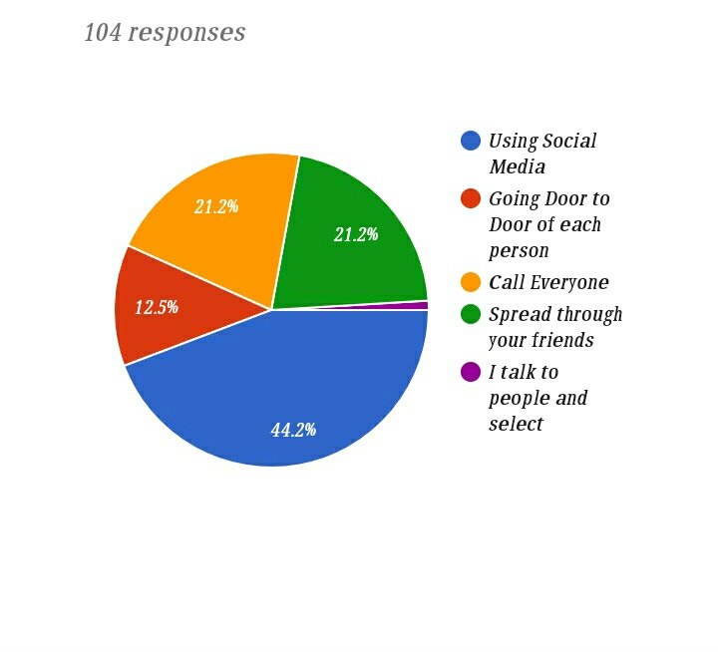

**Conclusion:**

1. Out of 10, how much difficulty you face in contacting and collecting interested people for such kind of activities?
2. - 1%
3. – 1%
4. – 6.7%
5. – 7.7%
6. – 17.3%
7. – 19.2%
8. – 27.9%
9. – 10.6%
10. – 5.8%
11. - 2.9%

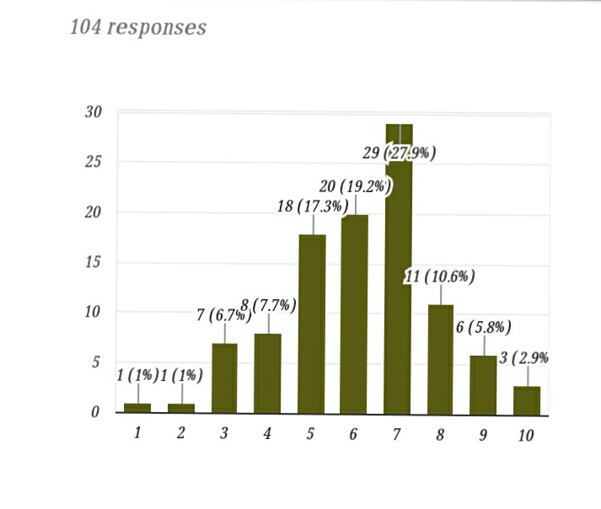

**Conclusion:**

1. On Average how much time (in minutes) does it take to contact and gather all the people?

**Conclusion:**

1. Would you appreciate mobile application which can reduce your efforts to just few seconds?

a) Yes 80.8%

b) No 18.3%

c) Maybe 1%

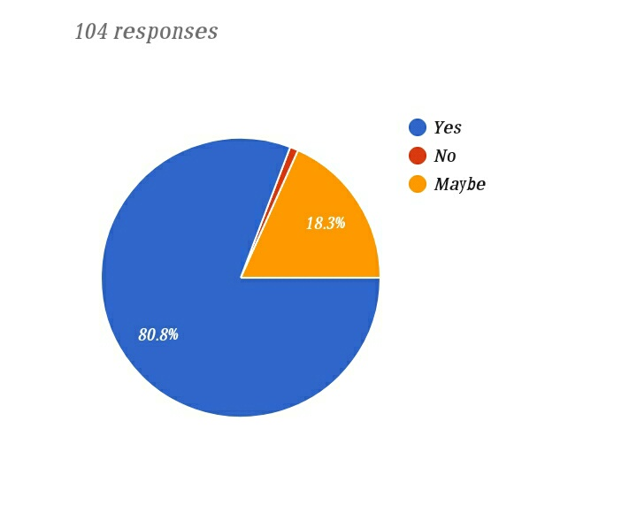

**Conclusion:**

**6)** How often do you need to gather people from nearby colleges (PDPU, GNLU etc)?

a) Never 46.2%

b) Very Few 46.2%

c) Frequently 4.8%

d) Most of the times 2.9%

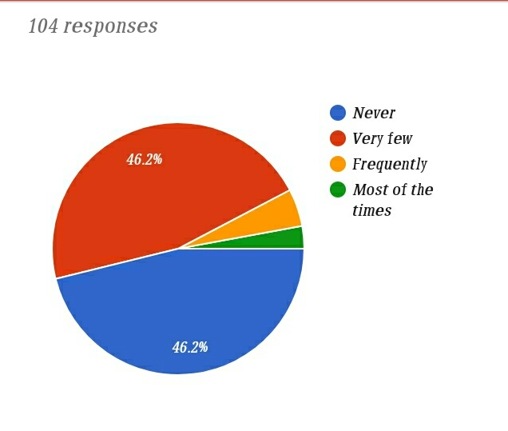

7) If you need people from nearby colleges also ,then these people can be:

a) Anyone interested 63.3%

b) Some selected people only 36.7%

**Conclusion:**

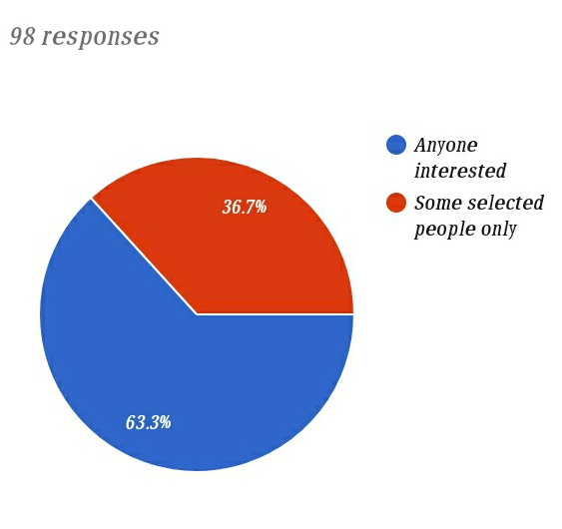

**Conclusion:**

**8)** Are you holding any position of any club (Sec/J. Sec) or Committee (Member)of our college?

a) Yes 73.1%

b) No 26.9%

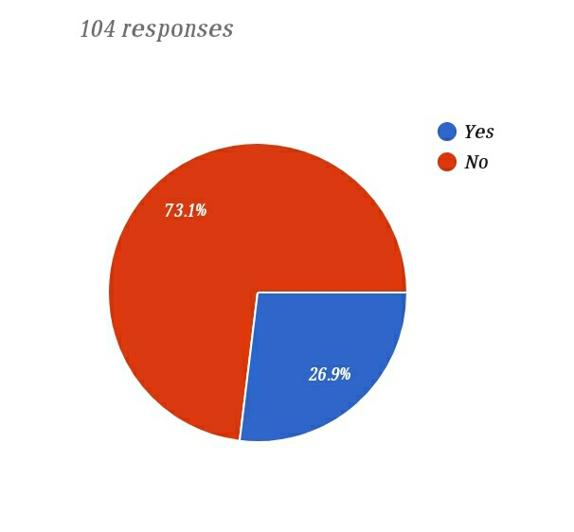

**Conclusion:**

9) How difficult it is to notify students for some Unofficial Events?

1 - 7.1%

2 - 21.4%

3 - 35.7%

4 - 32.1%

5 - 3.6%

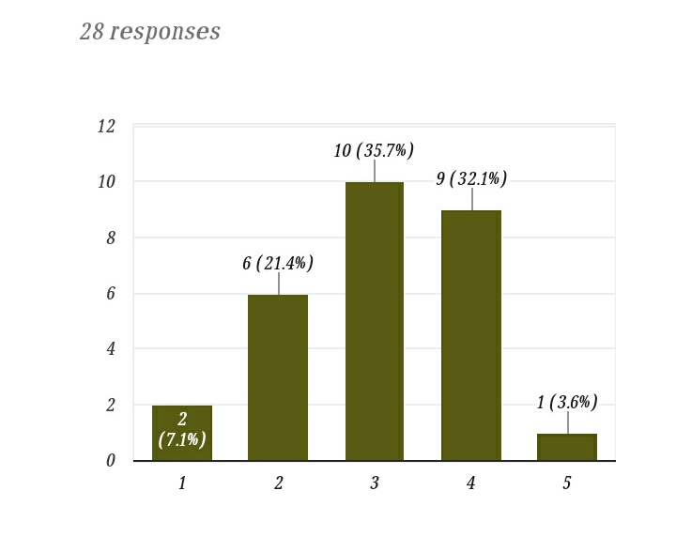

**Conclusion:**

10) How difficult it is to find Volunteers for any events?

1 - 0%

2 - 17.9%

3 - 32.1%

4 - 35.7%

5 - 14.3%

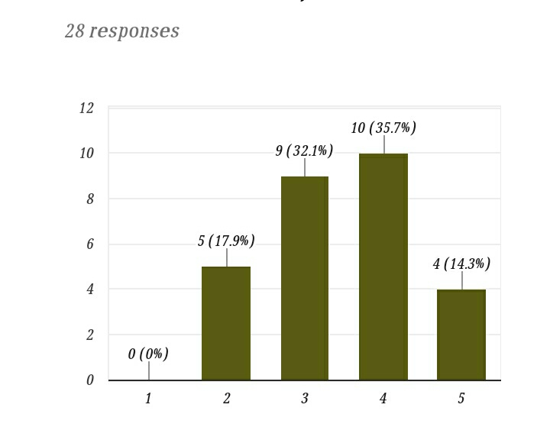

**Conclusion:**

11) On scale of 5, how much helpful this Application will be if we help you in notifying participants and volunteers?

1 - 3.6%

2 - 3.6%

3 - 14.3%

4 - 57.1%

5 - 21.4%

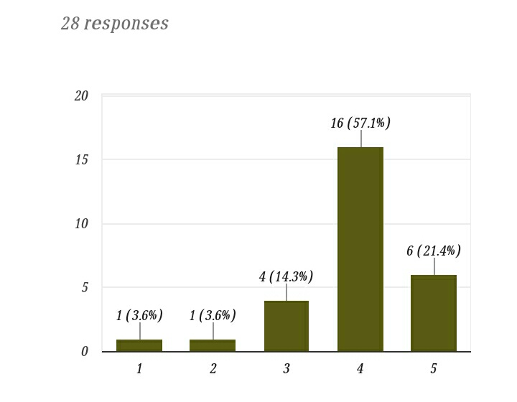

**Conclusion:**